Drink Your Malk
RULES: Practical Shooting Handbook, Latest Edition COURSE DESIGNER: Kirt McKenna
START POSITION: Standing outside of the shooting area, facing downrange, toes on X’s. Handgun is loaded and holstered.
PCC Start: Same as Handgun with carbine loaded, safety on, stock on belt, and muzzle facing downrange.

STAGE PROCEDURE  On Start Signal engage targets as they become visible from within the shooting area. Steel must fall to score. | SCORING  SCORING: Comstock, 32 rounds, 160 points  TARGETS: 14 USPSA, 4 Steel  SCORED HITS: 2 Best per USPSA, Steel KD = 1A  START-STOP: Audible - Last shot  PENALTIES: Per current USPSA Rule Book

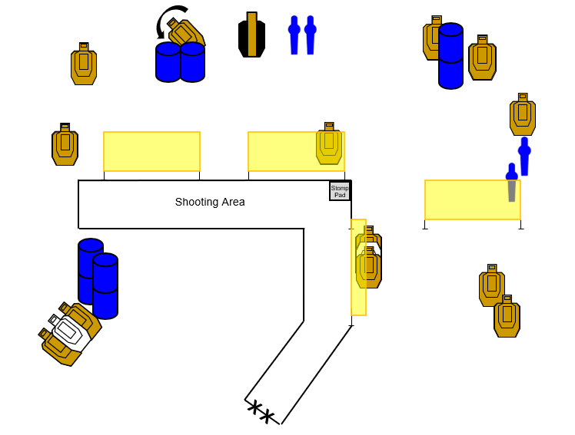

SETUP NOTES: |  | RO NOTES: None

